Emporia Community Arts Alliance
CALL FOR ARTISTS 2024

The Emporia Community Arts Alliance has issued the 2024 Call for Artist for a new, site-specific mural. To apply, please complete and submit this application form and all additional requirements. You may send questions and completed application to the Director of Visit Emporia, LeLan Dains at lelan@visitemporia.com.

The Emporia Art Alliance is made up of volunteers that represent a variety of art organizations in Emporia. The group has come together to enrich and promote Emporia through the arts.

Find out more about Emporia Public Art at visitemporia.com/place/public-art

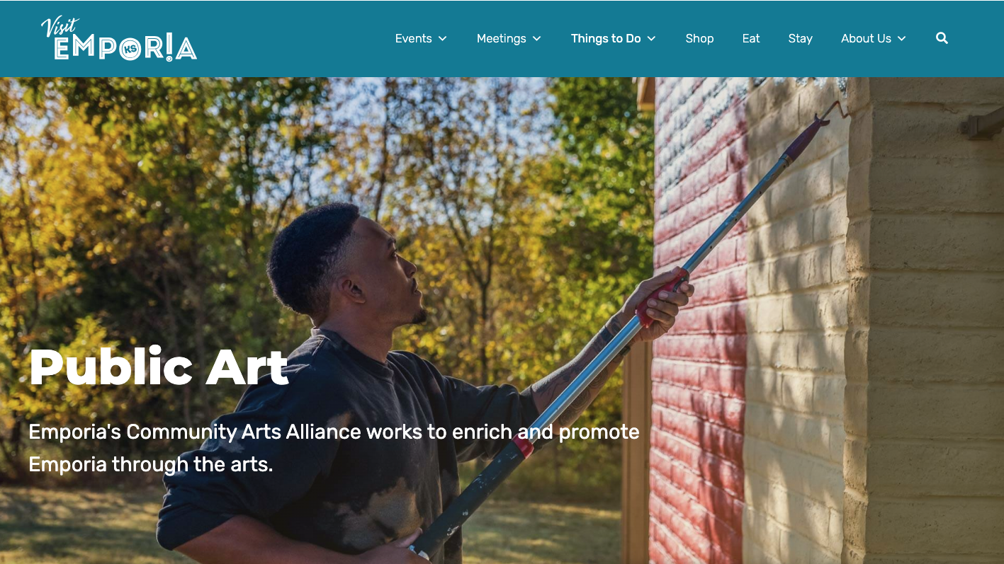

Mural Location
North facing wall at 11 West 9th Ave, Emporia Kansas 66801
Entire wall is approximately 80 feet wide by 30 feet tall.

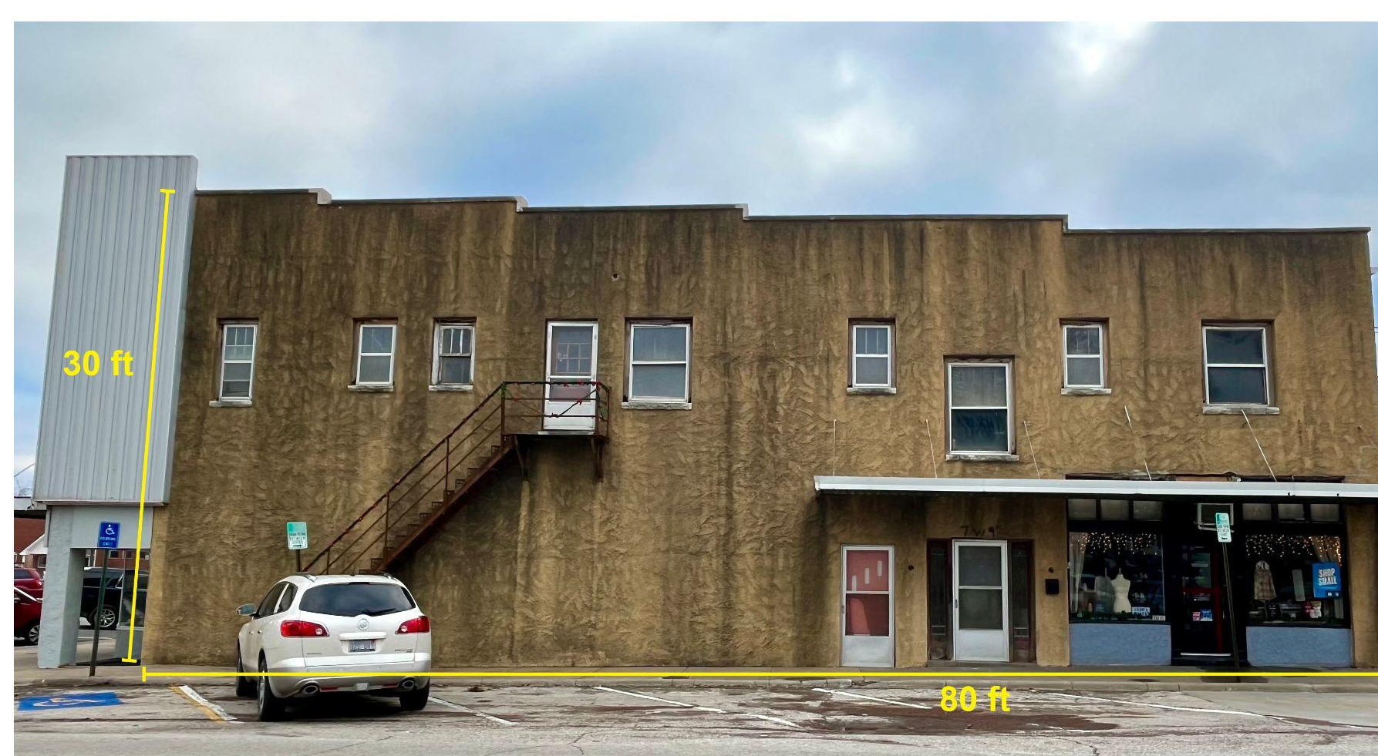

Detail of wall surface
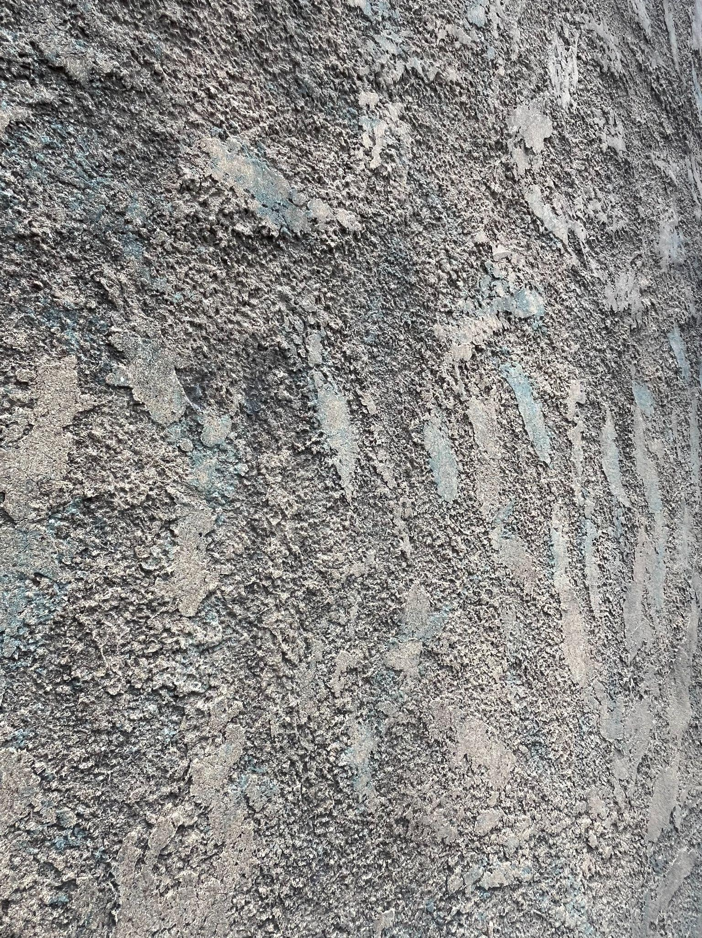

Concept
Premium consideration will be given to potential murals that:
- Tell a story, or
- Illustrate the local identity, uniqueness, and arts and culture assets of the Emporia community, and
- Enhance the public and pedestrian environment of Emporia through artistic expression by utilizing an attractive layout and color combinations.

Visual imagery must be appropriate for all audiences (not containing advertising, partisan politics, sexual or religious content).

Requirements
Completed Call for Artists Application by March 22, 2024 and the following supporting materials.
- To scale, full-color rendering (no larger than 8-1/2” x 14”) of proposed design, including any text.
- Short narrative of the proposed work/project.
- Lead artist’s qualifications and examples of previous work.
- Work plan that includes surface preparation, primer, paint system and description of materials to be used.
- Timeline for completing the project.
- An estimate of costs associated with the project including but not limited to: surface preparation, paint/materials, scaffolding, and labor costs.

CALL FOR ARTISTS APPLICATION

Artist Information
Artist Name (If Team Submittal, Lead Artist Name):

Company (If Applicable) :

Mailing Address (City, State, ZIP):

Cell Phone or Home/Office Phone:

Email:

Link to Artist’s Online Portfolio OR submit three photos of previous murals:

Team Artist Information
Additional Artist Names:

Artist References
Client Name:

Client Phone Number/email:

Additional Requirements
- To scale, full-color rendering (no larger than 8-1/2” x 14”) of proposed design, including any text.
- Short narrative of the proposed work/project.
- Lead artist’s qualifications, link to online portfolio OR submit three photos of previous murals
- Work plan that includes surface preparation, primer, paint system and description of materials to be used.
- Timeline for completing the project.
- An estimate of costs associated with the project including but not limited to: surface preparation, paint/materials, scaffolding, and labor costs.

