Emporia Community Arts Alliance
PROJECT PROPOSAL

Thank you for your interest in creating public art in Emporia! This project proposal template has been designed as a tool to help artists bring potential community art projects to life. You are welcome to copy this document and add to it directly, or use it as a guide in the creation of your own proposal. Either way, we ask that you address all components in great detail. The Emporia Community Arts Alliance welcomes innovative and creative proposals, but also aims to hold each submission to a high degree of quality. Please take the time to think through your project extensively, addressing the important items listed on this proposal template. Understand that quality projects will take time to dream and develop. There are many moving parts, especially when it comes to community art. You may send questions and completed project proposals to the Director of Visit Emporia, LeLan Dains at lelan@visitemporia.com.

The Emporia Art Alliance is made up of volunteers that represent a variety of art organizations in Emporia. The group has come together to enrich and promote Emporia through the arts.

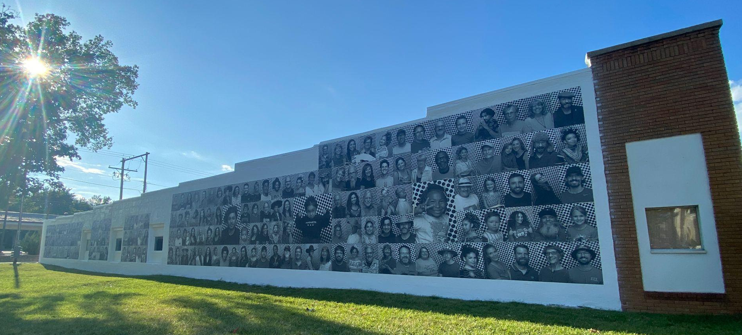

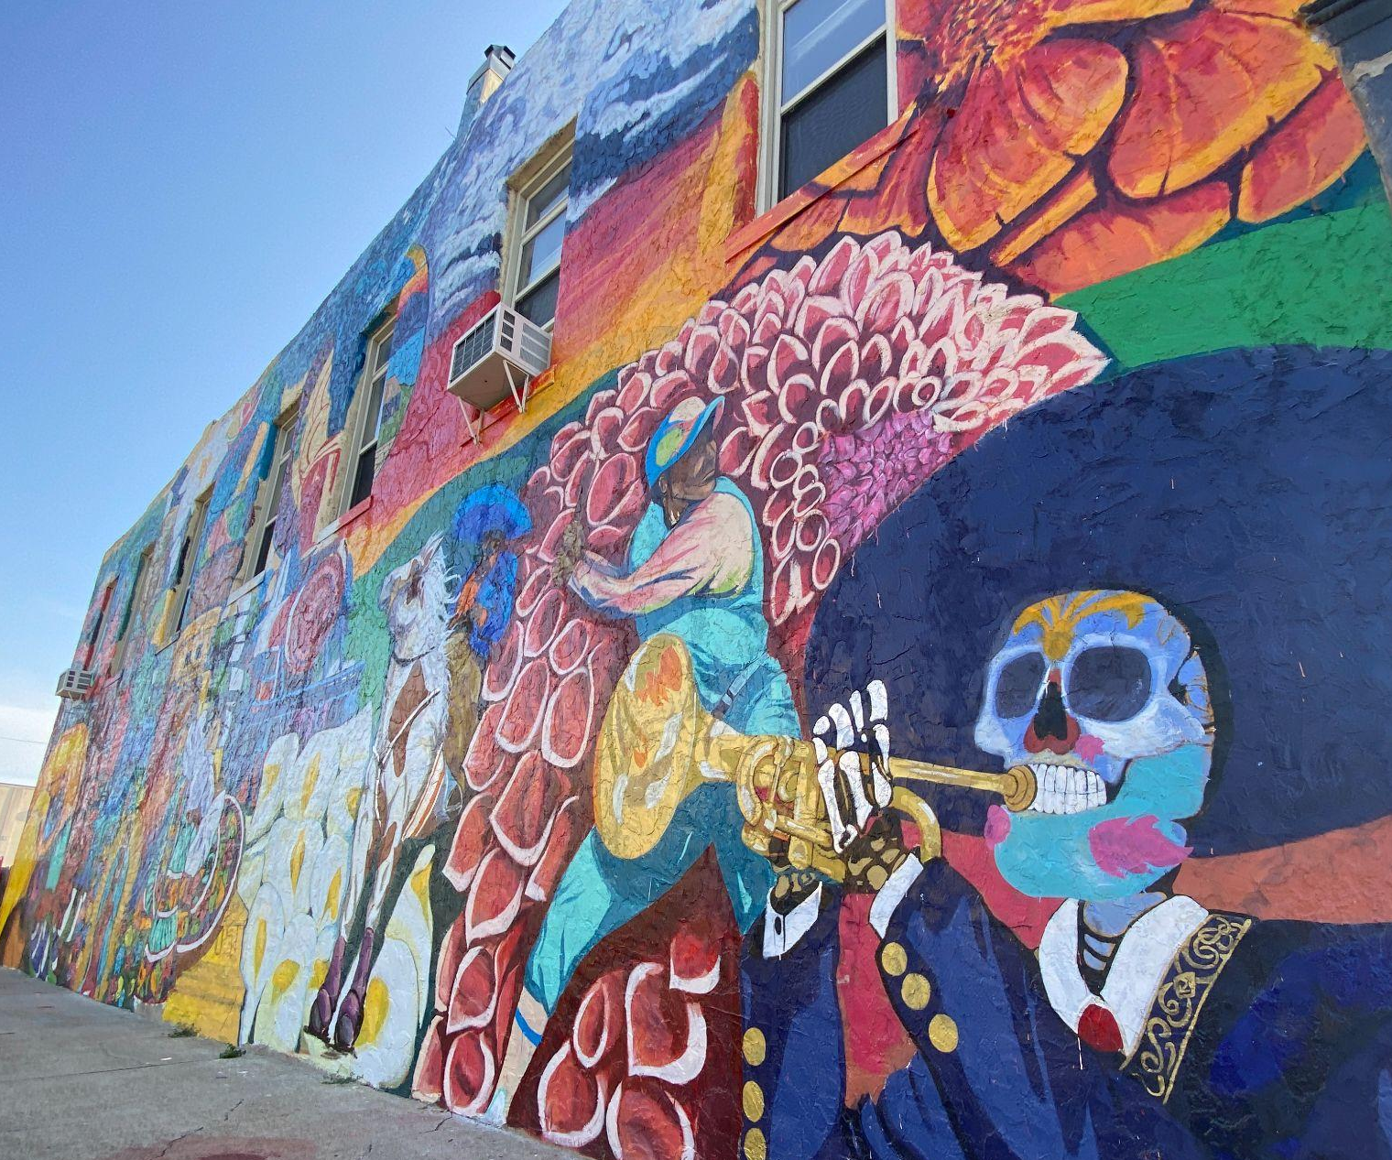

Project Name

Date:
Name:
Email:
Phone:

Overview
This is your chance to tell us about your project. Here are some questions and thoughts to help guide your proposal.
- Why do you want to have public art in your community?
- Who is your primary audience (locals, tourists, children, etc)?
- What impact do you want this artwork to have for this population?
- What is the theme of the mural?
- Does it speak to and reflect the audiences who will see it?
- What is the purpose and vision of this artwork?

Specifications
This is your chance to show us that you have done your homework and that your project is ready for funding. When applicable, provide documentation.
- Do you have a site determined?
- Have you gained permission from the property owner? Provide a signed letter of support from the property owner to indicate their permission for the project.
- Do you have community partners to help develop the project? Or will you be working alone?
- Who is the artist? Include a resume and portfolio for the project artist.
- Will the community have input on the design but the artist will execute?
- Will the artist create a master design and volunteers will assist with the painting?
- Will the entire process be lead and executed by the artist?
- Are there design approvals needed from local officials, a design council, the building owner, etc?
- How many revisions is an artist expected to produce as part of the agreed upon fee?
- How much creative freedom does the artist have?
- Do you have or need a staging area, if so how accessible is it?
- Is the artist contracted for any repair or maintenance or will the host organization be in charge of that?
- What if the artwork is vandalized – who is responsible for repair?
- Is a State Historic Preservation Office (SHPO) review required? You can find out more from the SHPO office.
- If landscaping or groundwork will be conducted on the site, is it extensive enough to require an environmental impact review? More resources on this are available from the National Endowment of the Arts
NHPA-NEPA Questionnaire

Budget
A detailed budget must be provided. You may create your own and include separately, or use the template below. Questions and thoughts to consider:
- Discuss with the artists their fee rates. Budgets influenced as much by time and process considerations as well as mural size.
- Consider any special equipment or materials that may be necessary (scaffolding, lifts, shade, etc).
- If you have already received grant funding, please provide documentation.
- If you have applied for a grant, please provide information, especially regarding announcement date.
- Please provide documentation (signed letter of intent) if you have received private sponsorship for the project.
- The Emporia Arts Alliance cannot guarantee 100% funding for projects. Alternative funding strategies should be considered.

*This is only an example. This may not be inclusive of everything you need to consider for your project.
Project Name: Bob's Mural
Revenue
Item | Quantity | Cost | Ext Cost
Visit Emporia Art Alliance | 1 | $4,000.00 | $4,000.00
Private Sponsor | 1 | $3,500.00 | $3,500.00
Super Cool Grant | 1 | $2,000.00 | $2,000.00
 |  | Total | $9,500.00
Expenses
Item | Quantity | Cost | Ext Cost
Artist Fee | 1 | $6,000.00 | $6,000.00
Paint | 1 | $750.00 | $750.00
Painting Supplies | 1 | $1,000.00 | $1,000.00
Lift Rental | 5 | $250.00 | $1,250.00
Misc | 1 | $500.00 | $500.00
 |  | Total | $9,500.00

Additional Resources
It is important to do ample research and to be as informed as possible before undertaking a project. Here are some additional resources worth investigating.

- Community Art: A Look at Public Art in America by the National Endowment for the Arts

- SHPO Mural Guidance
  - Downtown Emporia Historic Building Registry
  - Emporia Historic Building Registry

- KCAIC Mural and Public Artist Roster

- KCAIC Mural and Public Art Grant

- Kansas Tourism Mural Listing

- City As Living Laboratory

